“The Easy Fat Loss Diet” By Neil Major

Macronutrients & Micronutrients
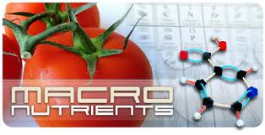
Protein, Fat, and Carbohydrates are all just different food groups. Macronutrients is just the scientific name for these different groups all of which we eat in our diet. Our bodies require others nutrients too, such as vitamins and minerals. These are called micronutrients. All three macronutrients & micronutrients are vital in our diet, however if understood properly they can easily be manipulated to drastically lower store body fat.
Protein
Protein is VERY important, we need it to keep and develop lean muscle. The more lean muscle we have the faster our metabolism burns off fat. If you lose muscle you will gain more fat as a result. Amino acids are the building blocks of protein. They are linked together in complex formations. There are 20 different amino acids, 9 of which are considered essential because our bodies cannot produce them naturally, and therefore they must be obtained through the diet. Proteins that contain all 20 amino acids are called complete proteins. Complete proteins are found in animal products such as meat, eggs and milk.Proteins role includes building, maintaining and repairing body tissue. It is especially important to physically active individuals whose muscle tissue is constantly in need of repair.
Fat
The misconception about fat is that it is always bad for you. In fact, fat is essential for maintaining a healthy body. Your diet should consist of about 20 percent fat. The trick is to eat more of the good fats and less of the bad fats. Saturated and trans fats should be avoided while increases levels of unsaturated and the essential fatty acids, such as omega 3 and omega 6, can be good for you. Replacing sweets and high fat meats with foods such as nuts, avocados, and olive oil will help shift the balance away from unhealthy towards those fats that are useful to the body.
Fat has many roles in the human body. One of fats main functions is protection. This includes insulation to keep body temperature and cushioning to protect body organs. It also promotes growth and development, as well as maintaining cell membranes. Fat, in addition, plays a vital role in the digestion of vitamins. Vitamins A, D, E, and K are fat-soluble vitamins, meaning they need fat in order to be absorbed into the body.
Carbohydrates
Carbohydrates are the main energy source of the body. They are chains of small, simple sugars that are broken down and enter the body as glucose. Glucose is essential for the body, as it is the preferred source of energy in our brain, heart and central nervous system. For this reason, you need some carbohydrates in your diet.

How Eating More Burns Fat
(Thermogenic Effect Of Food)

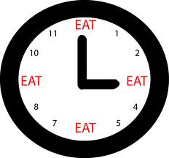

It may shock you to hear that not all Calories are created equally. Depending on where you get your Calories from, you may actually be getting less Calories than you think.
The Thermogenic Effect of food is a term used to refer to the way that the foods you eat can increase the amount of heat your body generates as it digests them, resulting in an increased metabolism for a short amount of time.
At its most basic level, the Thermogenic Effect is a result of your body having to use energy to digest food.
Protein is top of the list of macronutrients, as far as the Thermogenic Effect goes. 25-35% of the calories you consume from protein are used in the process of digestion. Most of this is attributed to the fact that the protein has to be broken down into amino acids. If you were to consume 300 Calories in pure protein (protein powder), the Thermogenic Effect would burn off 81 of those calories just during the act of digestion, leaving you with 219 calories.
Carbohydrates are next. Calories consumed from carbohydrates experience a 7% (on average) Thermogenic Effect. This is quite a bit less than Calories from protein, but it's still one more win against the "carbohydrates make you fat" theory. Part of the reason the Thermogenic Effect is so much lower for carbohydrates is that carbohydrates, in terms of human physiology, has been the food of choice longer than proteins. It tends to be more bioavailable, and depending on the glycemic index of the carbohydrate (whether the energy is released very quickly or very slowly), the Thermogenic Effect may be more or less than 7%. Low GI carbohydrates tend to have a slightly higher Thermogenic Effect because they are actively dispersing energy over a longer period of time. Yet another reason to avoid refined sugars--they're all very high up on the glycemic index.
Fats are in third place of the hierarchy. They have a low Thermogenic Effect of 3%, on average, meaning that the Calories you think you're getting are, for the most part, the Calories you are getting. Fat is the most bioavailable macronutrient, hence the low amount of energy needed to make use of it. However, this does mean that it is a good idea to not eat many fats. Fats will help you stave off hunger longer, and during the early stages of human evolution, fat was rare and very nutritionally valuable. With 9 Calories per gram and only 3% of those Calories being consumed during digestion, it was an extremely portable, nutritionally dense treat. It is possible to survive on a very high-fat diet, and even mostly replacing all protein with fat, as the Inuit and Eskimo have done for thousands of years. While this is not a good idea, it is possible.
The Thermogenic Effect has a lot to do with your eating habits. If you eat only one meal a day and don't eat breakfast, you are greatly reducing the Thermogenic Effect .Instead, eat several (6-8) smaller meals, spread thoughout your day spacing them as evenly apart as possible 3 hour is my preferred time. Eating in this way consistently can further increase the metabolism via the Thermogenic Effect.

Water & Fat Loss
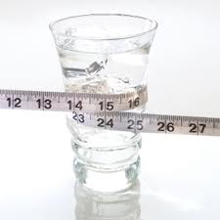
Water is an appetite suppressant. Drink enough water and you only get hungry when you need to eat.
When dropping to very low body fat percentages, you can’t eliminate hunger, but you can limit it. Drinking an abundance of water keeps hunger at bay for as long as possible.
Your kidneys need plenty of water to carry out body fuctions. If they don’t get this water, the liver comes into play to help.
Since the liver is responsible for taking your stored fat and turning it into energy you can use, you will slow this process down by relying on your liver. You can therefore increase fat loss by drinking enough water and letting your liver get on with the job of turning unwanted fat into fuel.
When you start getting lean, the body’s internal alarm notices the lack of food. It will then fight back trying to hold onto fat stores. Your energy levels drop and your body temperature lowers making you feel cold. Drinking enough water (2-3 litres) will help counteract this.
By giving the body a steady amount of water you limit this unwanted effect by telling the body that there is no emergency, there’s plenty of water around and it’s safe to let go of that fat.
Thermogenesis is the process of heat production by the body. Most weight loss pills are thermogenic aids i.e. they increase thermogenesis, which is a fancy way of saying they help you burn more Calories at rest.
Increasing the production of warm fluid (urine) will also burn more Calories. More frequent trips to the loo can be a good thing.Hydrated muscles are strong muscles. This leads to better workouts and more growth stimulation. Holding on to (if not building) muscle while lowering fat keeps your metabolism high as muscle is metabolically active tissue.

Understanding the Cheat Day
It's important that you don’t spend the whole day once a week eating whatever you like. Instead, you should pick one day (usually the weekend) during which you will one treat meal. This can include the main meal or a dessert--but not both.
Benefit: Less Likely To Slip Up Often
When you plan a cheat day in your diet once a week, you can look forward to rewarding yourself for your hard work. Every time you feel the temptation throughout the week to break your diet, you'll be able to remind yourself that you will have that treat on your cheat day and you'll find the strength to stay strong more so than if you'd told yourself you can never touch that unhealthy food again.
If you don't have any cheat day to look forward to, you can be at risk of a binge. You could find yourself spending days overeating and eating unhealthy food that's not on your plan.
Benefit: Increases Your Motivation To Lead A Healthy Lifestyle
Knowing that you can still enjoy one of the unhealthy foods you love at some point each week will make the fact that you're on a diet less of a punishment and more about living a new, healthy lifestyle that can still be fun. Getting fed up or lacking motivation to stick to a healthy diet and exercise plan can cause you to stray off of your plan. Taking one week off of your diet and exercise routine can undo a month's worth of work to drop fat and build lean muscle in your body. Rewarding yourself can help give you the focus and determination you need to succeed during the rest of the week.

The Easy Fat Loss Plan:

Recommended Eating Times

Meal 1 : 7:30am Protein & Carbs
Meal 2 : 10:30am Protein
Meal 3 : 1:30pm Protein & Carbs
Meal 4 : 4:30pm Protein
Meal 5 : 7:30pm Protein & Fat
Meal 6 : 9:30pm Protein (Snack)

Alter this as needed but try to stick to the eat or snack every 3 hours rule to keep your metabolism high.
Drink at least one large glass of water with each meal and 2-3 litre throughout the reminder of the day.
Be consistent with this as your body will revert back to it’s old programming if you miss just a day or so.
For the first week try setting an alarm on your watch or phone to beep every 3 hours.
Do not have any alcohol or fizzy drinks diet or otherwise with the exception of sparkling water. The chemicals in such drinks are seen as toxins within the body and it takes the livers focus away from fat burning whilst you detoxify.

Breakfast Options

Neil’s Power Porridge
½ -1 Cup Of Oats
25-40g Whey Protein (Any Flavor)
Mix With Boiling Water Or Warm Almond Milk

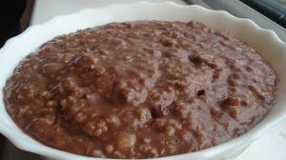

Neil’s Fitness Cereal
Muesli
Oatabix
Oatbites
1-2 Scoops Of Whey Protein Mixed With 150ml Water Poured Over As A Milk Alternative (Any Flavour)

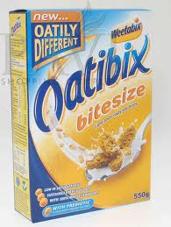

Scrambled Egg Whites On Rye Bread

1 Whole Egg & 2-3 Whites Only Scrambled With Coconut Oil Placed On A Rye Base With A Grilled Tomato

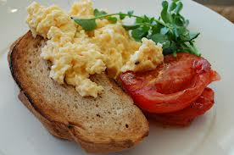

Mid Morning Snack Options

Protein Shake 1-2 Scoops With Water

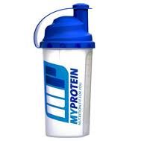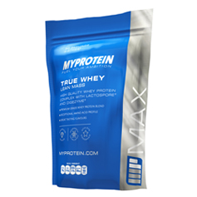
Fruit/5 Almonds

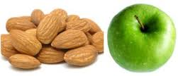

1-2 Oat Cakes

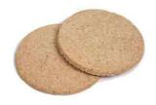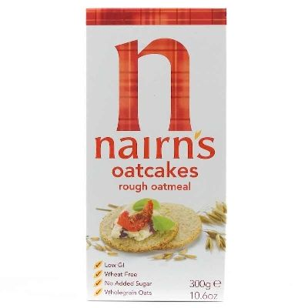
Lunch Options

Tuna Nicoise Salad
1-2 Boiled Eggs Chopped Onto A Base On Spinach Rep Peppers & Onion Mixed With Tuna & Balsamic Vinegar Or Extra Virgin Olive Oil

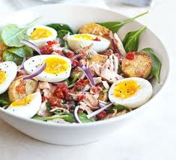

Chicken Salsa Salad
Grilled Chicken Breast Mixed With Salad Leaves And Natural Salsa

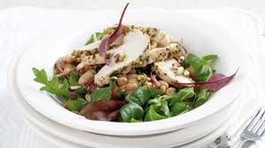

Tofu Salad
Diced Tofu Mixed On A Base On Spinach & Peppers

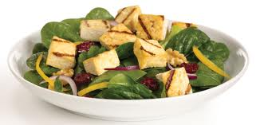

Afternoon Snack Options

½ -1 Protein Bar

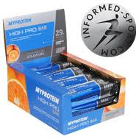

5 Almonds

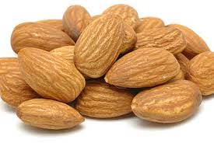

Cottage Cheese Ryvita
Spread A Medium Sized Amount Of Low Fat Cottage Cheese Onto 1-2 Pieces Of Ryvita

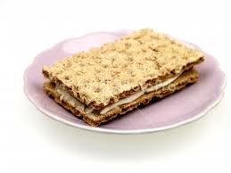

Evening Meal Options

Salmon With Asparagus
Oven Baked Salmon Seasoned With Lemon Placed On A Base Of Chopped Salad And Grilled Asparagus

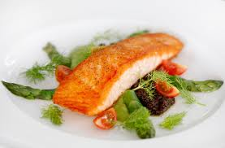

Lean Steak Salad
Grilled Lean Sirloin Steak Placed On Chopped Salad & Avocado Dressed With Apple CiderVinegar

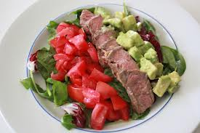

Chicken Stir Fry Cayenne Style
Stir Fried Veg Mixed With Chopped Chicken Breast Seasoned With Cayenne Pepper

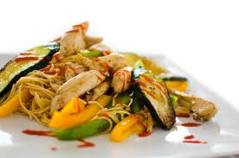

Vanilla Whey Protein With 0% Yogurt

1 Small Pot Of Total 0% Yogurt Mixed In A Bowl With 1-2 Scoops Of Whey Protein (Any Flavour)

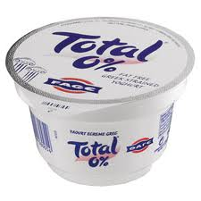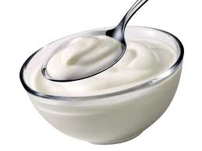

Fat Burning Supplements & Why They Work

Whey Protein

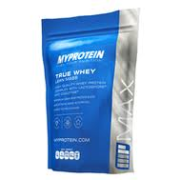Buy Here

Whey protein enhances fat burning and reduces body fat
by Jeff S. Volek, Ph.D., R.D.

People are encouraged to take protein for the main reason it increases muscle protein synthesis. But higher protein diets may also play a role in fat burning.

A recent report from the Netherlands concluded that there is a connection between increasing protein intake and fat burning, and that such an effect promotes favorable effects on body composition.

Men and women with normal weight were randomized into two groups. The control group consumed 59g of protein (from regular food) per day for three months. The higher protein group consumed 80g of protein (59g from regular food plus 21g from whey and casein protein) per day for the same length of time. The diets all contained adequate calories so that weight remained stable.

After three months, body composition remained unchanged in the control group. However, the higher protein group lost 2.6 pounds of body fat and gained 3.3 pounds of lean body mass. The researchers also determined the subjects’ maximal rate of fat burning during exercise. The higher protein group increased this rate by 16%, whereas the control was unchanged.

These findings confirm other studies showing that diets higher in protein improve body composition by promoting maintenance of lean body mass and loss in fat mass. This study is unique as it was conducted with individuals with normal weight who were not restricting calories.

In summary, increasing protein intake beyond the recommended dietary allowance is associated with increased fat oxidation and decreased fat mass.

To Buy Whey Protein Click Here >>> MyProtein <<<

CLA

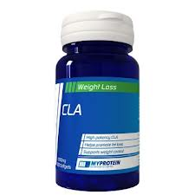Buy Here

What is it?
Often overlooked as a fat-loss supplement, it's only recently begun to be touted as one of the most underrated supplements on the market. For that reason, CLA might be worth taking a second look at. Over two decades of research have shown CLA may significantly help reduce bodyfat, and there's even recent evidence to support that it increases muscle tissue. Primarily, though, athletes and people who are weight conscious have begun supplementing with CLA because it's been shown in research to significantly shift body composition in favor of fat loss and muscle gain.
How it works
When leading CLA researcher Michael W. Pariza from the University of Wisconsin-Madison was asked, "How does CLA work?" he replied, "In a general sense, what it's doing is keeping little fat cells from getting big... perhaps by blocking certain enzymes that let fat cells swell."
Leading researchers have suggested that CLA's body-composition-altering effects are likely due to its ability to regulate the metabolism of fat through a fairly complex process having to do with our bodies' enzymes (namely, lipoprotein lipase and hormone-sensitive lipase). The long and short of it is that CLA appears to block fat uptake and then increase the speed of fat burning.
What does the science say?
Recently, Ola Gudmundsen of Scandinavian Clinical Research presented a study that suggests CLA could help people lose weight, primarily by reducing overall fat mass. In this groundbreaking study, 60 overweight people who were not allowed to diet were randomly assigned to take either a nine-gram placebo of olive oil or 1.7 grams, 3.4 grams, 5.1 grams, or 6.8 grams of CLA daily for 12 weeks. Their body composition was measured at the start, middle, and end of the study. "We saw that they had a significant reduction in weight in the CLA group," says Gudmundsen, "...about 2.2 lbs in 12 weeks." Even more promising, the researchers found that this loss was overwhelmingly from bodyfat and didn't affect overall weight or body mass index.
Another supportive study, conducted by Thom Erling, Ph.D., measured subjects' bodyfat and bodyweight over a three-month period. In this double-blind, placebo-controlled study, the first group took CLA at breakfast, lunch, and dinner. The second group took a placebo. At the end of three months, the CLA group lost an average of five pounds, which was not considered statistically significant. But, their bodyfat dropped by an impressive 15% to 20% compared to the placebo group who experienced little change.
In a brand new study presented at the Experimental Biology meetings this year, scientists gave mice either CLA or CLA plus the herbal stimulant guarana (which contains caffeine). What was interesting is that although the CLA group dramatically reduced the adipocyte (fat cell) size, the CLA plus the addition of guarana reduced the fat cells by an incredible 50%—in just 6 weeks. Can you use just a plain old cup of coffee and CLA for the same effect? The answer unfortunately is no. The caffeine in most drinks only has a short-lived boost, while guarana gives an extended release, thus benefiting you for many hours.
How to take it
Most researchers agree 3,000 mg (three grams) divided into three dosages per day with meals is necessary for fat reduction. On the bonus side, 3,000 mg to 6,000 mg (three to six grams) divided into three dosages per day with meals has been shown in recent studies to help induce muscle-tissue growth.
To Buy CLA Click Here >>> Buy Here <<<

Green Tea Extract

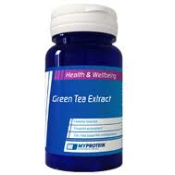 Buy Here

Green tea extracts have recently caught attention for a range of positive effects in the human body, which range from improved cardiovascular health to increased fat burning. Scientific evidence supports the use of the extract to improve the rate of fat burning as a result of increased thermogenesis.

Green Tea Components
David Tolson, a nutritional researcher and contributor to Bulk Nutrition, explains how green tea remains the world's most popular drink after water. He notes how the green tea leaves, which come from the camelia sinensis plant, contain a range of components; the leaves contain both chlorophyll, responsible for the characteristic green hue in the drink, and catechins.

Extracts
As the active component, manufacturers of green tea supplements standardize the products for their catechin content. The plant chemicals, which make up around 10 percent of the leave's dry weight, act as antioxidants inside the body and can aid the health of the immune and cardiovascular system. They can also effect the fat-burning process.

Fat Burning
Many factors influence the rate of fat burning in the body, including the balance between fat storage and fat burning enzymes. Dr David Bender, a biochemist from London's Imperial College, explains how the rate of thermogenesis has a large impact on the overall rate of fat burning in the body. Thermogenesis sees the body sacrifice its fat stores to increase the core temperature. The catechins in green tea can influence this process.

Catechins
Tolson highlights how the catechins, especially the potent epigallocatechin-gallate, can have a positive effect an the amount of fat burned. They inhibit the the enzyme that normally breaks down noradrenaline in the central nervous system, resulting in an increased availability of the peptide hormone. As noradrenaline binds to receptors to stimulate thermogenesis, these effects result in an increase in the process and in fat burning.

Evidence
Dr Abdul Dulloo led a team of researchers that looked into the effects of green tea extracts on the metabolism. Their results, which were featured in the "American Journal of Clinical Nutrition" in 1999, found that the herbal product caused a 3.5 percent increase in overall energy expenditure. Most impressively, the proportion of energy that came from fat jumped from 31 to 41 percent.

To Buy Green Tea Extract Click Here >>> Buy Here <<<

L-Carnitine

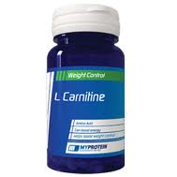 Buy Here

L-Carnitine supplementation may help you achieve optimum fat burning, in conjunction with a diet and exercise plan. By boosting energy production, increasing fatty acid oxidation and transporting nutrients into cells, L-carnitine helps the body burn fat. Carnitine supplements work best when combined with exercise, though they may exert some beneficial effects without it. Always consult with your doctor before taking any dietary supplements.

Function
L-Carnitine acts as a co-factor for the production of energy in the human body, according to Life Extension Magazine. An amino acid found in protein-rich foods, carnitine shuttles fatty acids from the bloodstream into the mitochondria of cells for oxidation. Oxidized fats create energy in cells, hence the term "fat burning." Organs with high energy requirements, such as the heart, muscles and liver, use large amounts of l-carnitine to continue functioning at optimal rates. Taking supplemental L-carnitine may boost fat burning for faster weight loss, according to "Supplements 101" by Jim Stoppanil, PhD.

The "L" form of amino acids identifies their molecular configuration and represents the basic purified substance, as in L-carnitine. The name of the substance denotes the form of the carnitine, along with any additional compounds that may be attached to the amino acid. For example, acetyl-L-carnitine is a form of the amino acid that offers the benefits of L-carnitine base, with additional effects on brain health. L-carnitine-L-tartrate is another common form of this fat burning amino acid. A new designer form of carnitine called GPLC (glycine priopionyl L-carnitine) may further improve fat burning through other pathways.

Effects
According to "Homemade Supplement Secrets" by Jeff Anderson, taking supplemental L-carnitine enables the transport of more fatty acids into mitochondria for fat burning purposes. L-carnitine may also have synergistic effects with fat-burning fats like CLA (conjugated linoleic acid) and omega-3 fish oil, which Anderson also recommends. GPLC may boost nitric oxide (NO) levels for more nutrient, oxygen and blood delivery to working muscle cells. Carnitine has also shown to boost the activity of muscle receptors for potent fat-burning hormones, according to Stoppani.

Benefits
Besides the fat-burning boost, L-carnitine supplementation may improve muscle building through several pathways. Building even a little metabolically active lean muscle mass ensures that you burn more calories every day because muscle takes a lot of energy to maintain. By enhancing energy production in muscle cells, carnitine may improve workout endurance, allowing your muscles to work longer and harder in the gym.
Recommendations
Stoppani recommends taking l-carnitine three to four times daily, 30 minutes before meals. Optimal times to take carnitine include with breakfast, before a workout, after a workout and/or with a night meal. Carnitine does not exert any stimulant effects, so you can take it within three to five hours of bedtime without losing sleep.

To Buy Any Of The Above Click Buy Here >>> Buy Here <<<

